**Name : Prajapati Arjun Course : Python Full Stack**

* Write SQL query to solve the problem given below

Consider a database containing two tables named as Customer and salesman

For this you need to create a customer table

In customer table attributes are customer id,customer name ,city ,grade and salesman id.

Table : Customer

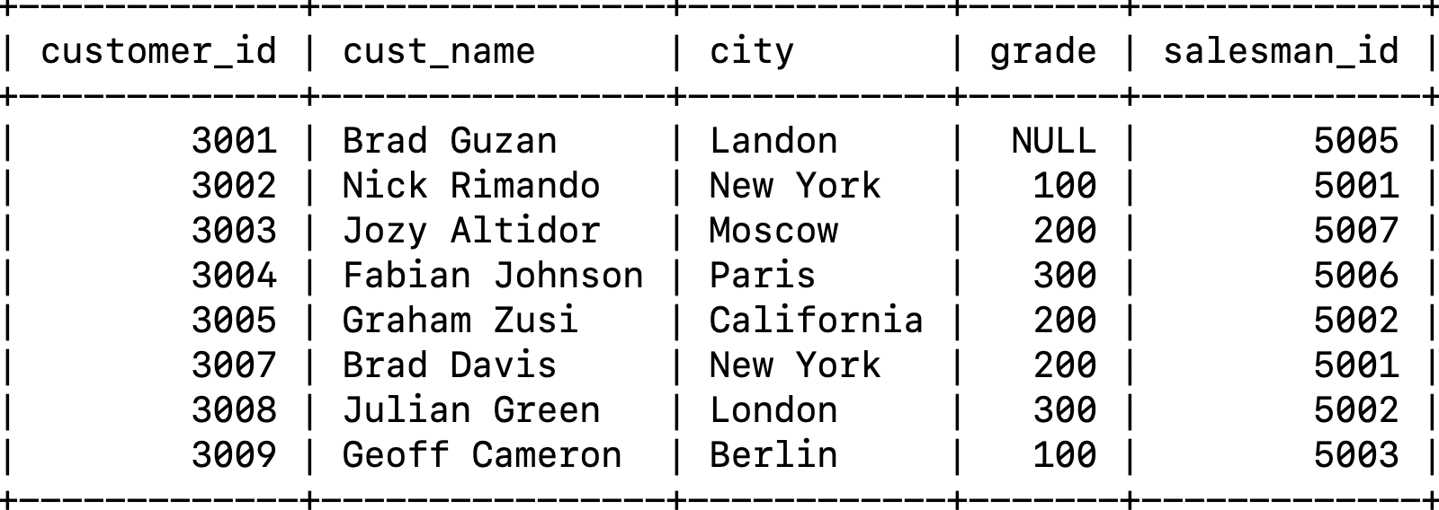

In salesman table attributes will be salesman id,city,and commission.

Table : Salesman

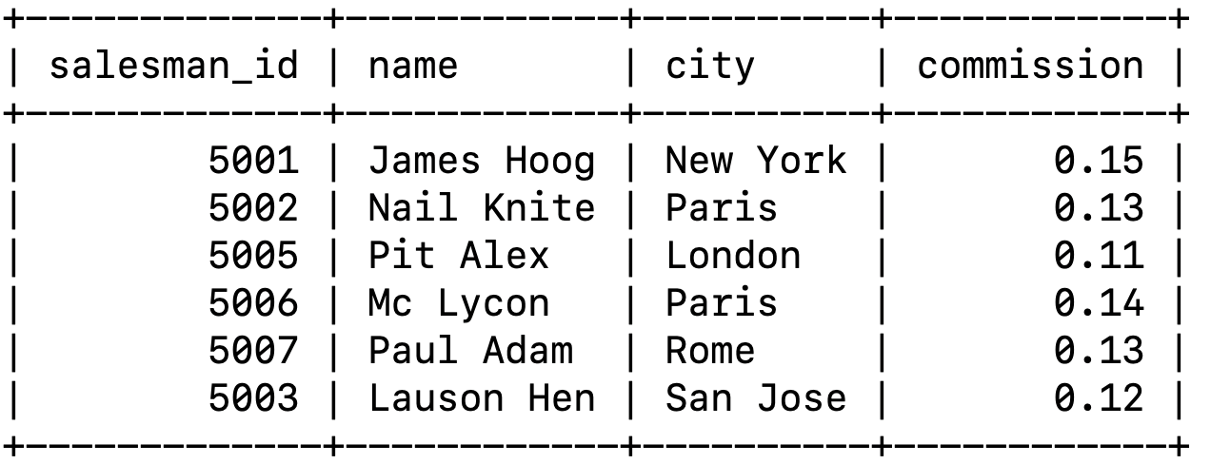

From the above given tables write a SQL query to find the salesperson(s) and the

customer(s) represented here. Return the Customer Name, City, Salesman,

commission.

NOTE : Make sure you have to use join concept to solve the query

Make sure to make your code clean kneat

**Answer :**

mysql> select customer.cust_name,

customer.city,

salesman.name,

salesman.commission

from customer

join salesman on customer.salesman_id = salesman.salesman_id;

